*Imperial College of Engineering*

(RU Affiliated)

Lab Report

BSC Engineering 1st year 1st semester Examination ,2024

Course code: CSE1112

Course title: Computer Maintenance and Engineering Drawing

|  |  |
| --- | --- |
| **Submitted to:** | **Submitted by:** |
| **Aparna Haldar** | **Name:Md.Rashidul Islam Zidan** |
| **Lecturer, Department of Computer Science & Engineering** | **Roll:23109** |
| **Imperial College of Engineering** | **Session:2023-24** |

Date: 18 /10 /2024

# INDEX

|  |  |  |
| --- | --- | --- |
| LAB NO | Content | Page |
| 01 | Assemble different  parts of a computer | 1-3 |
| 02 | Install different types of application software and utilities software. |  |
| 03 | Install different types of Operating System such as Windows 10 |  |
| 04 | Partition a computer hard disk. |  |
| 05 | Fault findings Detect hardware related problems in CPU and fine the solution. |  |
| 06 | Getting familiar with DOS and its commands. |  |

## Lab : 1

**“Assembling different parts of a computer”**

## Hard disk drive

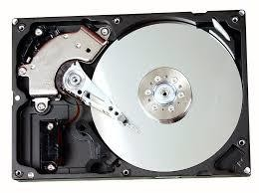

Hard disk drive

**A hard disk drive (HDD) is a data storage device used for storing and retrieving digital information using rapidly rotating disks (platters) coated with magnetic material. Data is written and read from the disks using magnetic heads positioned on moving arms. HDDs are commonly found in computers, laptops, and servers for long-term data storage.**

## CPU

**The CPU, or Central Processing Unit, is the primary component of a computer responsible for executing instructions and performing calculations. It acts as the brain of the computer, processing data and carrying out tasks required by software programs. The CPU interprets instructions fetched from memory, performs arithmetic and logic operations, and controls the flow of data within the system. It is typically a small, square-shaped chip located on the computer's motherboard.**

## Motherboard

**A motherboard is the main printed circuit board (PCB) in a computer. The motherboard is a computer's central communications backbone connectivity point, through which all components and external peripherals connect. Motherboards can be found in virtually all computers, especially desktop and laptop PCs**

## RAM/ROM

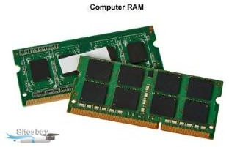

RAM

**Random-access memory, or RAM, is one of the most important parts of your computer. It provides high-speed, short-term memory for your computer's CPU. The amount of computer memory you need depends on what you use your computer for, but 12 GB of RAM is a good general minimum standard.**

CPU

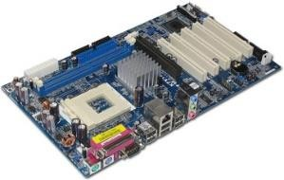

Motherboard

**Read-only memory, or ROM, is a type of computer storage containing non-volatile, permanent data that, normally, can only be read, not written to. ROM contains the programming that allows a computer to start up or regenerate each time it is turned on**.

## CD/DVD

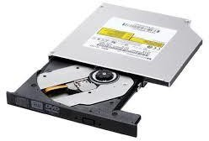**The full form of DVD is Digital Versatile Disc. DVD is a digital optical disc storage format which was developed and invented in 1995 and used to store high- capacity files, such as top-standard videos and movies.**

**compact disc (CD), a molded plastic disc containing digital data that is scanned by a laser beam for the reproduction of recorded sound and other information.**

DVD

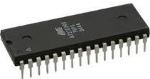ROM

## Keyboard, Mouse

**A computer keyboard is an input device used to enter characters and functions into the computer system by pressing buttons, or keys. It is the primary device used to enter text. A keyboard typically contains keys for individual letters, numbers and special characters, as well as keys for specific functions.**

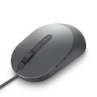

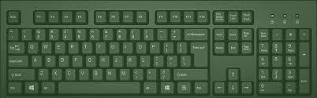

Keyboard

**A mouse is a small device that a computer user pushes across a desk surface in order to point to a place on a display screen and to select one or more actions to take from that position.**

## SATA Cable

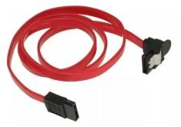

SATA Cable

**Serial Advanced Technology Attachment (SATA) or Serial ATA cables are used to connect devices in computer cable assemblies, such as storage devices, for example. The SATA technology itself is a connecter interface primarily used for computer bus connections in storage applications.**

## USB port

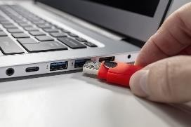**Definition: What a USB Port IsA USB port is a standard cable connection interface for smart phones, computers, and other consumer electronics devices. USB stands for Universal Serial Bus, an industry standard for short-distance digital data communications.**

**Mouse**

## Input device

**Input refers to any information or data that is sent to a computer for processing. It is often sent to the computer from a device such as a keyboard, mouse, or another device. Putting it simply, it is the act of entering data into a computer**.

USB port

## Output device

**Output is used to refer to the amount of something that a person or thing produces. Manual workers need a good breakfast for high-energy output. Government statistics show the largest drop in industrial output for ten years. Synonyms: production, manufacture, manufacturing, yield More Synonyms of output**

## Heat sink

**Heat sinks are widely used for cooling parts and components that produce heat while in use. The simple answer to the question, “What is a heat sink?”, is that it gradually transfers heat energy away from a heat source. So, in a sense, heat sinks are closely tied to electronics cooling.**

Mouse

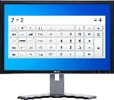

Monitor

Heat Sink

## Power supply

**A power supply unit is used to provide stable electricity. The device converts and supplies electricity of the required voltage and frequency, excluding noise from the electricity obtained from an electrical outlet. Power supplies are classified by applications for available DC, AC, and output voltage ranges.**

## Cooling fan

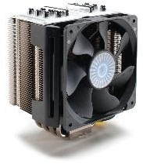

**Cooling fans are also known as panel fans, they are an ideal solution for application that requires high efficiency and silent operation. The cooling fans work by sucking the cold air at the bottom vent, and thereby realizing hot air from the top vent as the heat rises upward**

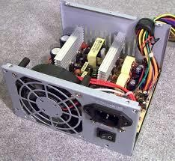

**Power Supply**

## Cooling fan